Name: Swaranjana Nayak

Reg No. : 19BCE0977

Date: 16 /10 / 2020

DBMS LAB CAT 2

Question 2

INSERTING AND CREATING TABLES

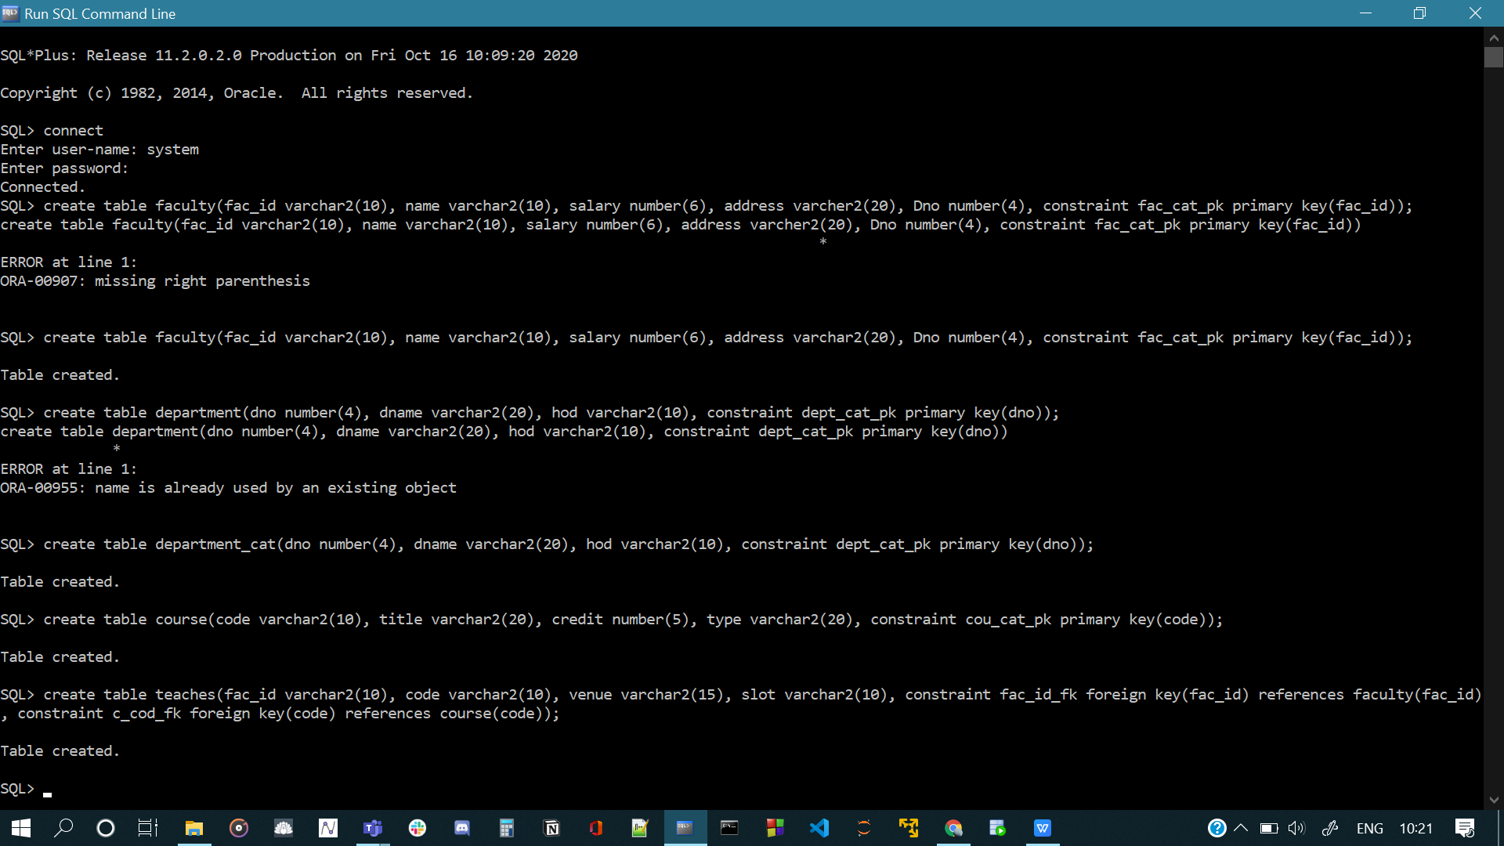

Faculty table

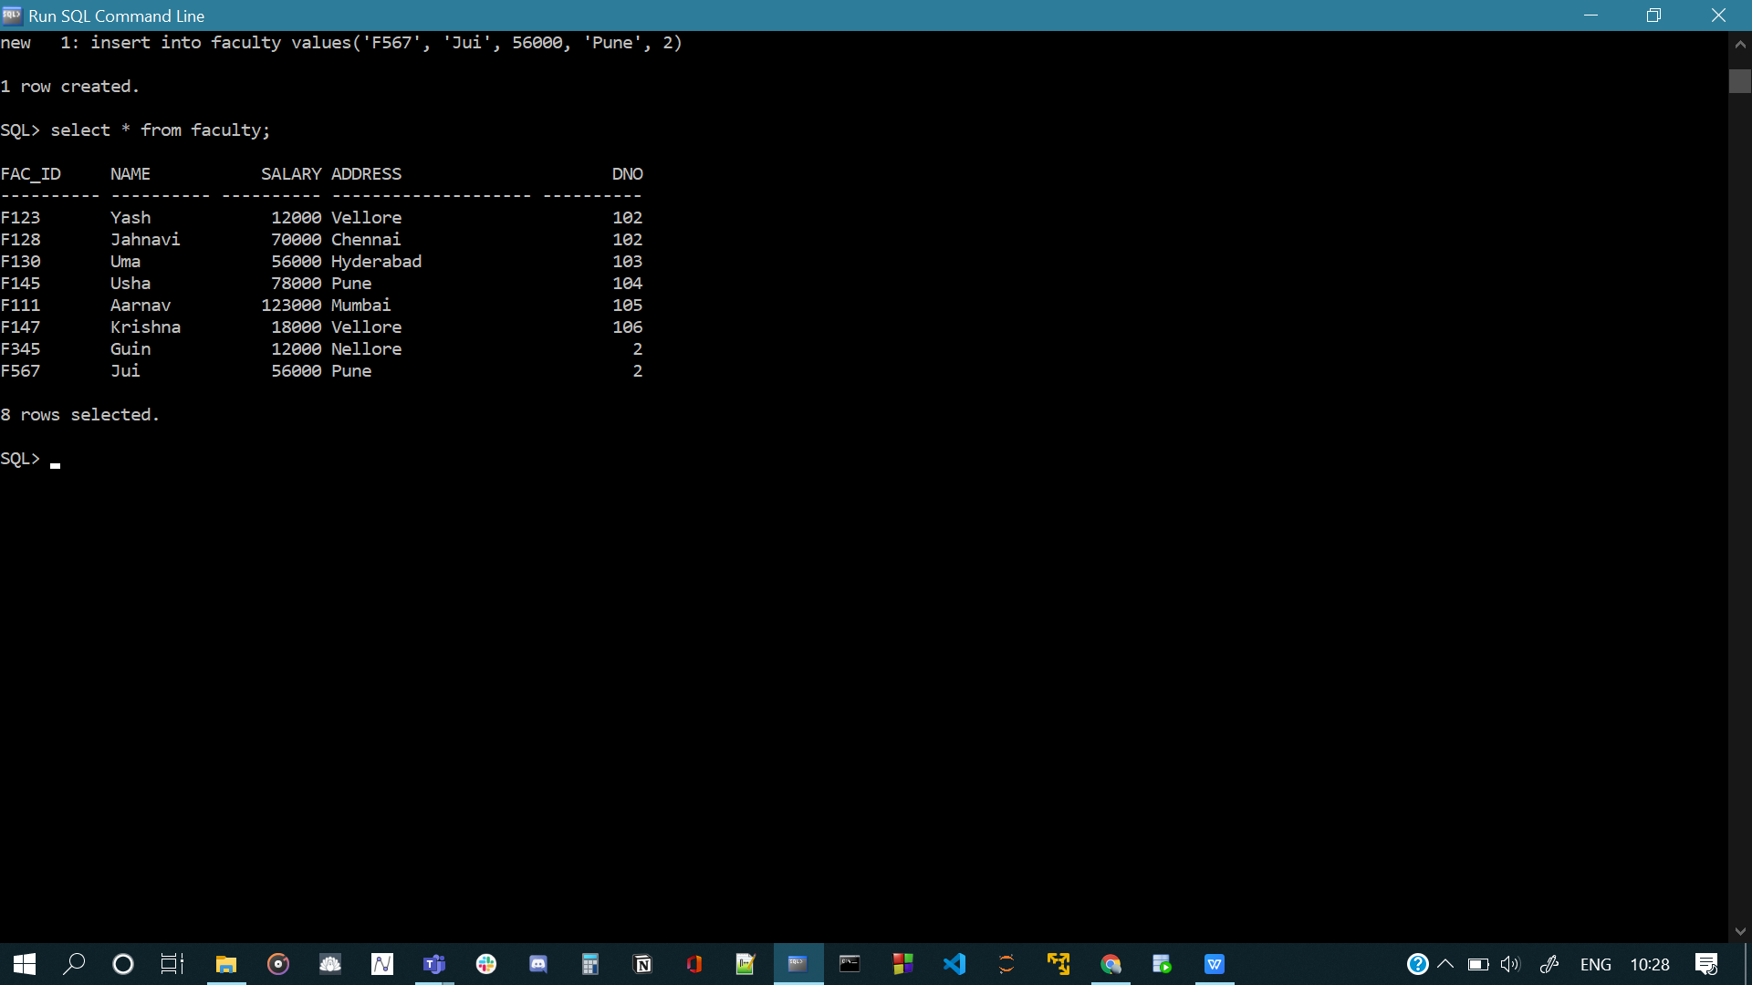

Department table



Course table

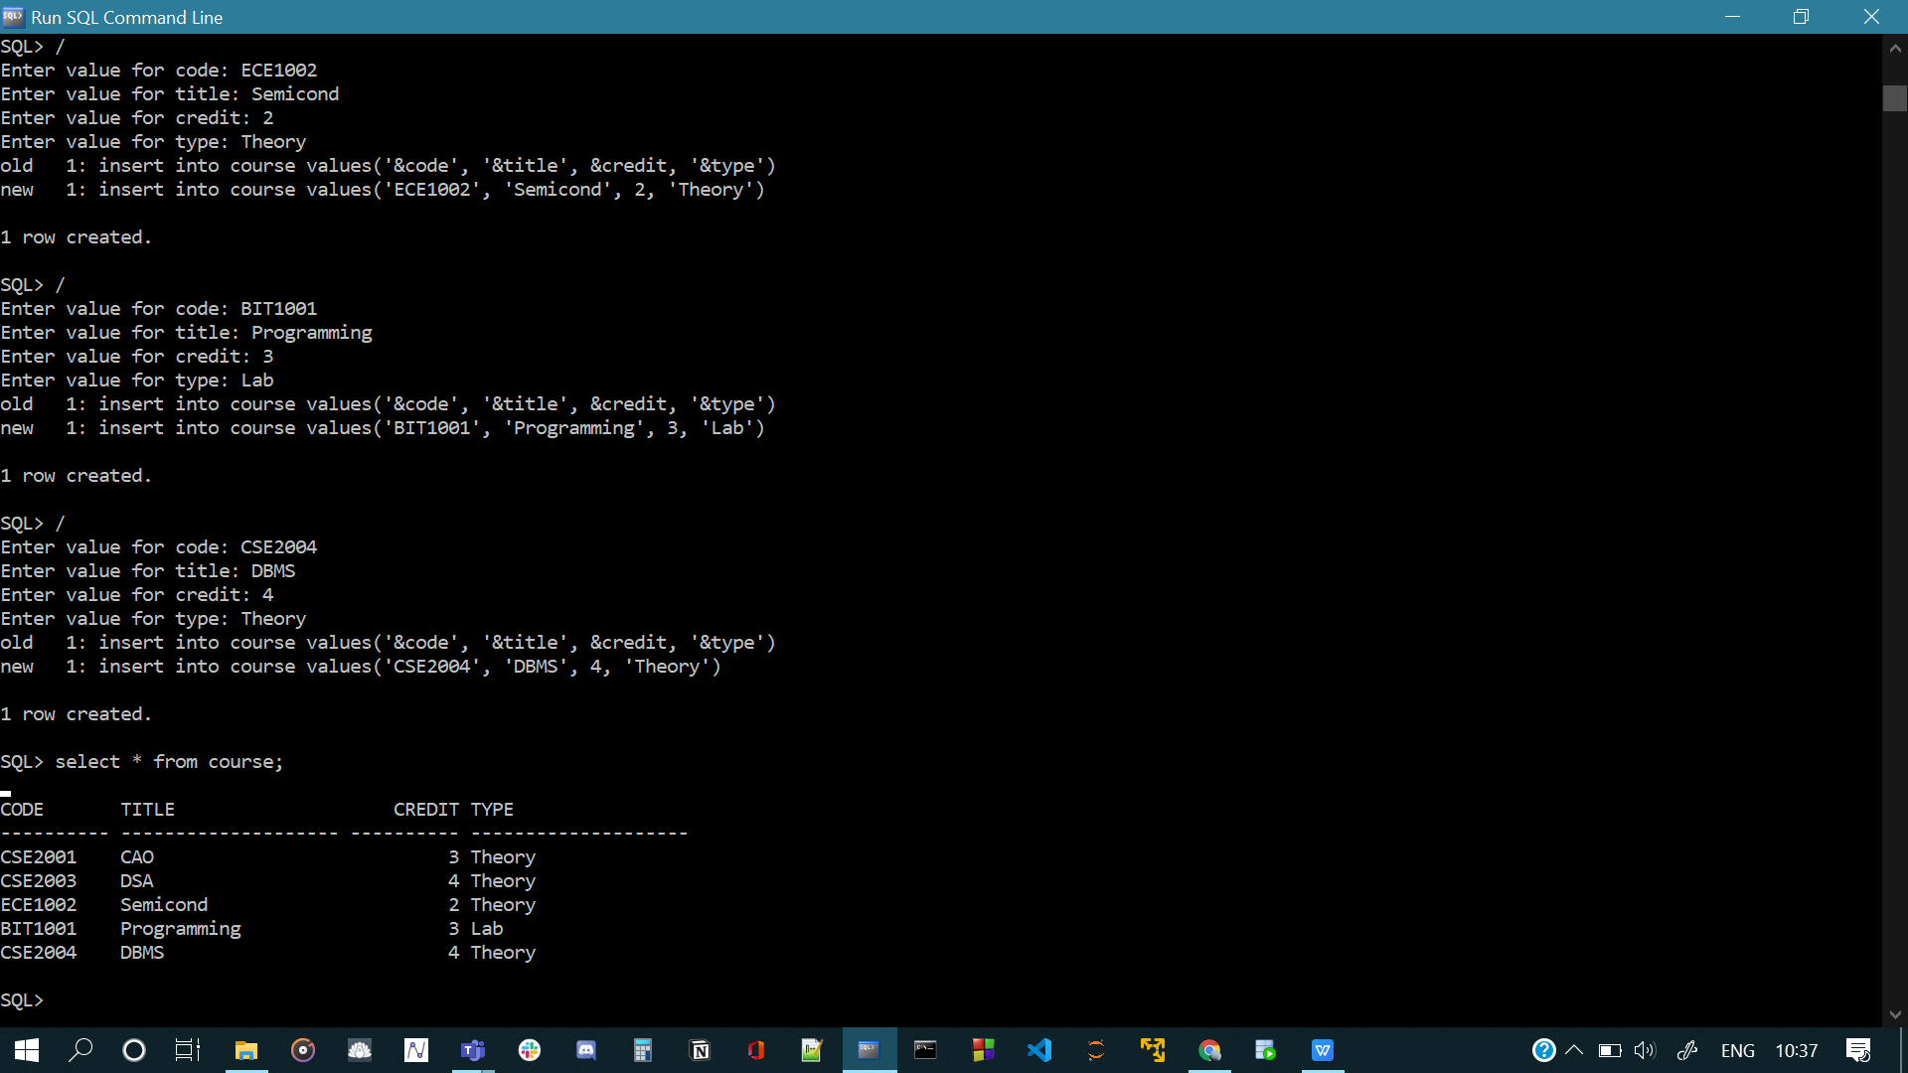

Teaches table

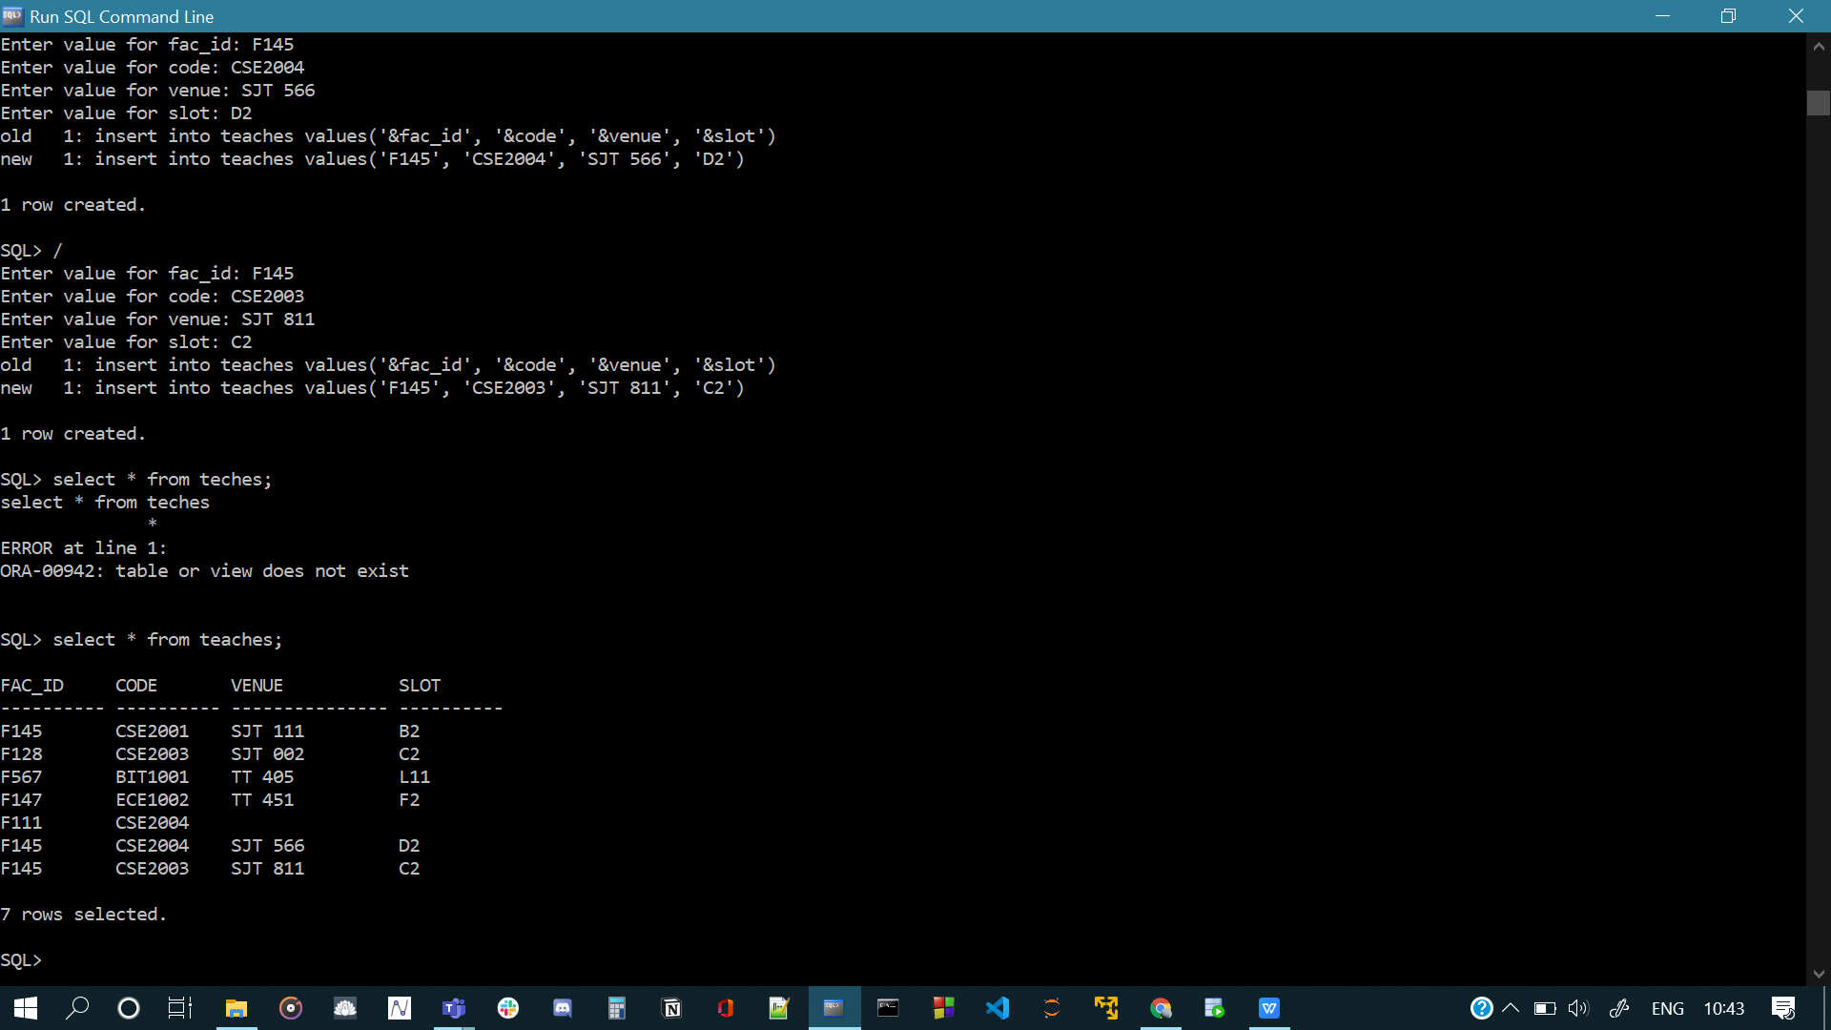

QUERIES

1. SQL> select name from teaches natural join course natural join faculty where credit > 3;

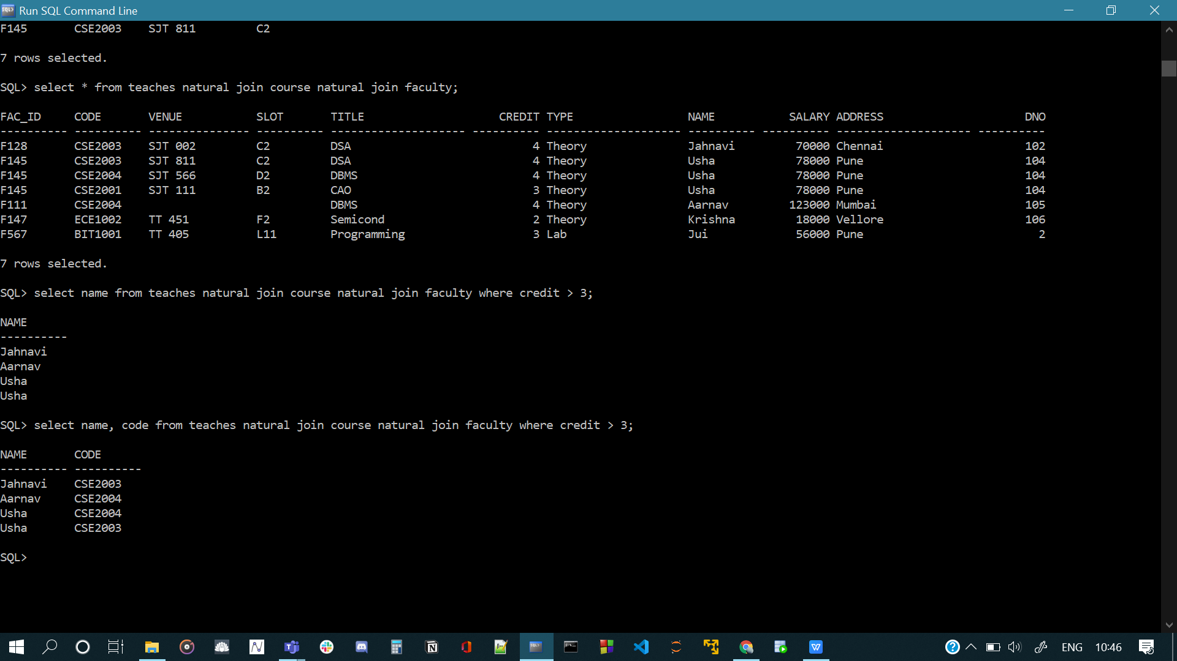

1. SQL> select fac_id, name from faculty where salary in (select max(salary) from faculty group by dno) and dno = 2;

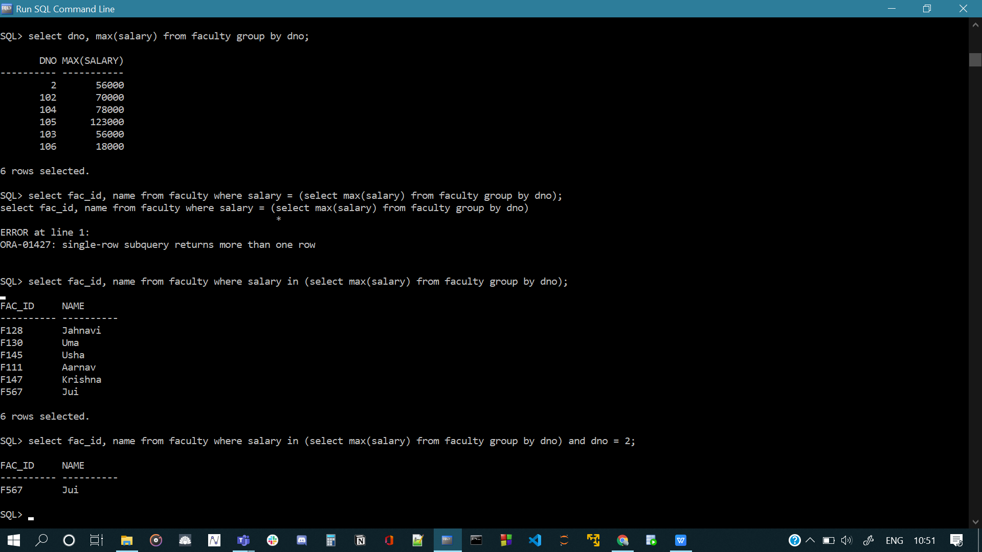

1. SQL> select fac_id, count(fac_id) from teaches group by fac_id;

create view dummy as select fac_id, count(fac_id) as counts from teaches group by fac_id;

select fac_id, name from dummy natural join faculty where counts > 2;

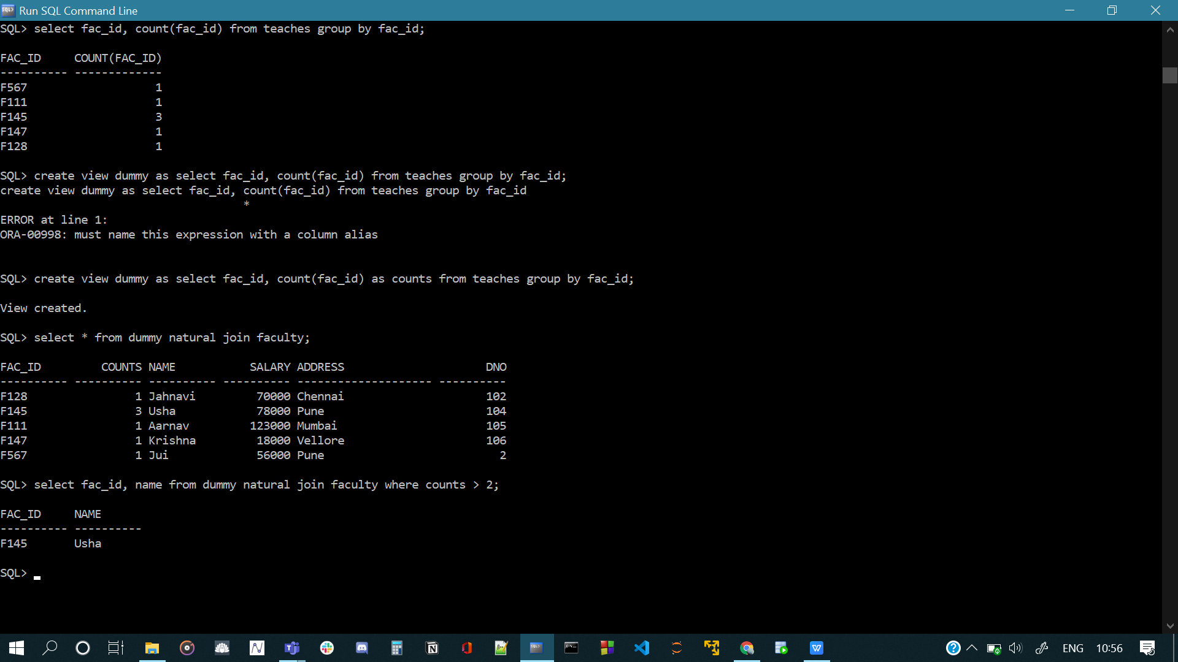

1. SQL> select fac_id, name, salary, dname, code from faculty natural join teaches natural join department_cat where name like 'S%';

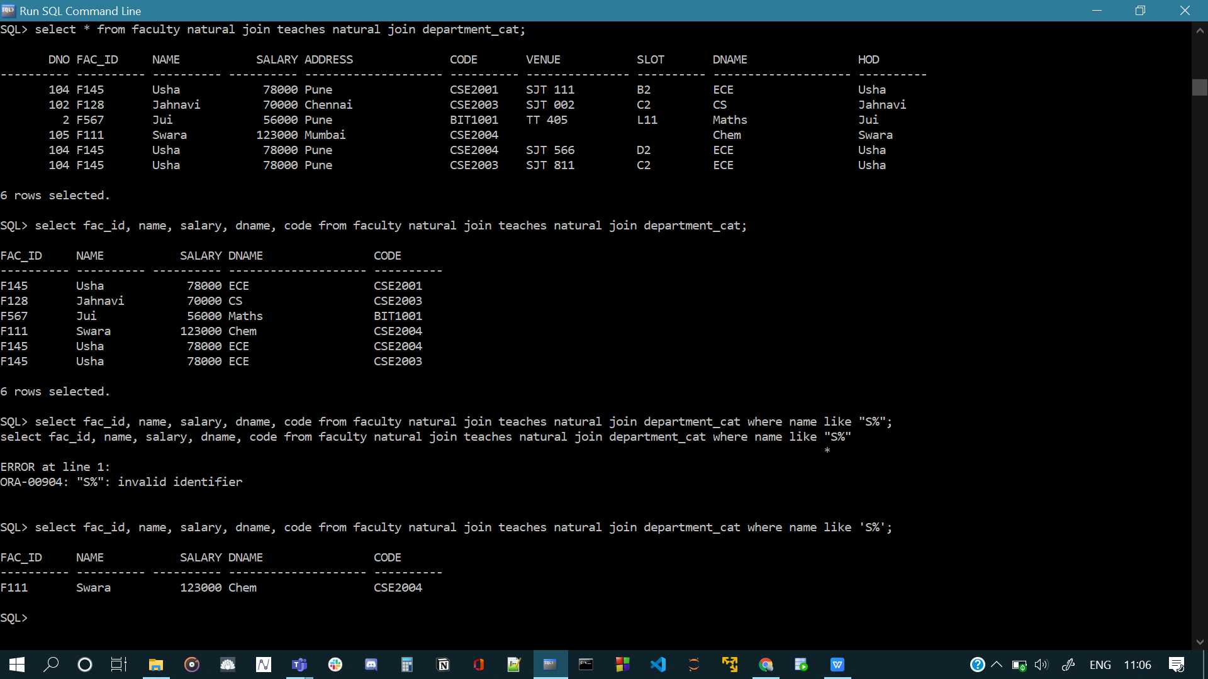

1. SQL> select fac_id from faculty minus select fac_id from teaches;



1. create view fun as select dno, count(dno) as counts from faculty group by dno;

select dno from fun where counts = (select max(counts) from fun);

